Extended Euclidean Algorithm

# Algorithm

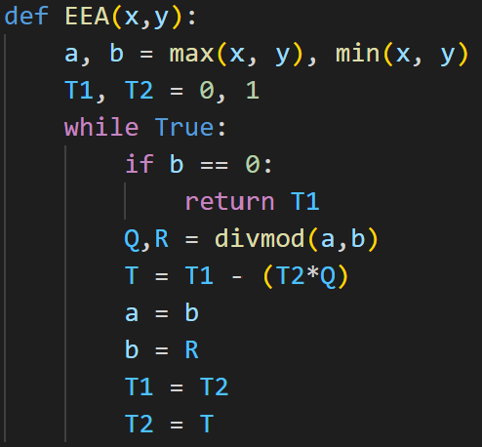

# Explanation

Above I created a function for the Extended Euclidean Algorithm and from looking at it you can see that the end condition for the function is when b equals 0. This means that the run time of the program is determined by how long it takes for b to equal zero. And we can see that every iteration the b value is being updated by the R value. And we get the R value from the modulus of a and b. This means that b is being reduced every iteration at the rate of a mod b and this means that the runtime of the algorithm is O(log(b)) and therefore polynomial.